Linked Stack
Implement a stack by a "linked list" as underlying data structure:
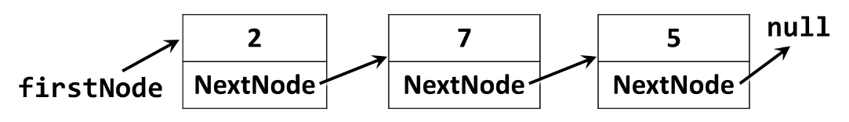
Use the following code as start:
public class LinkedStack<T>
{
private Node<T> firstNode;
public int Count { get; private set; }
public void Push(T element) { … }
public T Pop() { … }
public T[] ToArray() { … }
private class Node<T>
{
private T value;
public Node<T> NextNode { get; set; }
public Node(T value, Node<T> nextNode = null) { … }
}
}

The Push(element) operation should create a new Node<T> and put it as firstNode, followed by the old value of the firstNode, e.g. this.firstNode = new Node<T>(element, this.firstNode).
The Pop() operation should return the firstNode and replace it with firstNode.NextNode. If the stack is empty, it should throw InvalidOperationException.

